Chapter 14: Target 4.5 – Equity

Globally, there is gender parity in pre-primary through secondary education enrolment (**Table 14.1**). However, averages hide continuing country-level gender disparity. In one-quarter of low-income countries, for every 100 males, fewer than 87 females are enrolled in primary education and fewer than 60 in upper secondary, at which level only 25% of countries have achieved parity. Even where the gender enrolment gap is small, there is little information on the extent of segregated enrolment (**Focus 14.1**).

Table 14.1: Gender parity index of gross enrolment ratio, by education level, 2018 or latest available year

|  | Pre-primary | Primary | Lower secondary | Upper secondary | Tertiary |
| --- | --- | --- | --- | --- | --- |
| World | 0.98 | 1.00 | 0.99 | 0.98 | 1.14 |
| Sub-Saharan Africa | 0.99 | 0.96 | 0.90 | 0.84 | 0.74 |
| Northern Africa and Western Asia | 0.99 | 0.96 | 0.93 | 0.96 | 1.03 |
| Central and Southern Asia | 0.94 | 1.07 | 1.04 | 0.96 | 1.00 |
| Eastern and South-eastern Asia | 0.99 | 1.00 | 1.01 | 1.03 | 1.17 |
| Latin America and the Caribbean | 1.01 | 0.98 | 1.01 | 1.09 | 1.30 |
| Oceania | 0.98 | 0.97 | 0.90 | 0.90 | 1.41 |
| Europe and Northern America | 0.99 | 1.00 | 0.99 | 1.00 | 1.28 |
| Low income | 1.00 | 0.94 | 0.87 | 0.80 | 0.62 |
| Lower middle income | 0.96 | 1.03 | 1.02 | 0.96 | 1.05 |
| Upper middle income | 1.00 | 1.00 | 1.00 | 1.05 | 1.20 |
| High income | 1.00 | 1.00 | 0.97 | 1.00 | 1.25 |

Source*:* UIS database.

Global figures for gender parity across education cycles are easy to communicate but insufficient for identifying those left furthest behind. Intersecting disadvantage severely affects children and youth education opportunities. In low-income countries, females from the poorest 20% of households are consistently less likely to progress: 12 poor females attend post-secondary education for every 100 poor males. The ratio is much more favourable, although still not equal, for their richest female peers. Up to secondary education completion, the poorest females in lower-middle-income countries experience a similar if smaller gap, but their relative chances improve in post-secondary education, reflecting the fact average disparity at that level is at the expense of males in all but low-income countries (**Figure 14.1**).

Figure 14.1: Poverty exacerbates gender disparity in education

Median gender parity index, by education level, low- and lower-middle-income countries 2013–18

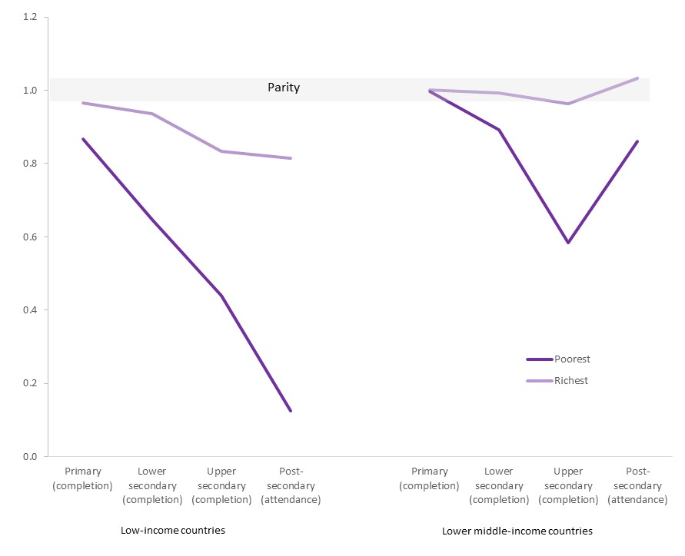

Source*:* World Inequality Database on Education.

How far countries let the most disadvantaged fall behind is evident in country rankings for an education indicator, for instance completion, and the value of that indicator for the most disadvantaged group by sex, location and wealth (usually the poorest rural females). The average lower secondary education completion rate is around 28% in Côte d’Ivoire and Rwanda, but while completion is close to zero among the most disadvantaged in the former, the latter does better, although still low in absolute terms (10%). Completion is marginally higher in Cameroon (43%) than Cambodia (40%), but it drops by 41 percentage points among the most disadvantaged in Cameroon, compared with a 25 percentage point drop in Cambodia. Similarly, Nepal does better than the Philippines (**Figure 14.2**).

Disparity by wealth commonly compares the bottom and top 20% of households, not of children. Yet, in most societies, poorer families have more children, on average: the poorest 20% of households tend to have more than one-fifth of all children. In India, the poorest 20% of households have 25% of all children, compared with 15% for the richest (**Figure 14.3**). In effect, the poorest and richest 20% of children are compared in Liberia vs the poorest 25% and richest 15% in Myanmar. Whether the attendance or completion gap by wealth is underestimated or overestimated is unclear. It depends on whether the poorest are less poor than thought (underestimation) or the richest are richer than thought (overestimation). Cross-country comparisons are similarly distorted if comparing the poorest 20% of children in one with the poorest 25% in another.

Figure 14.2: Countries with similar education indicator averages may differ in those left furthest behind

Country ranking in lower secondary education completion rates for the national average and most disadvantaged group, selected countries, 2013–18

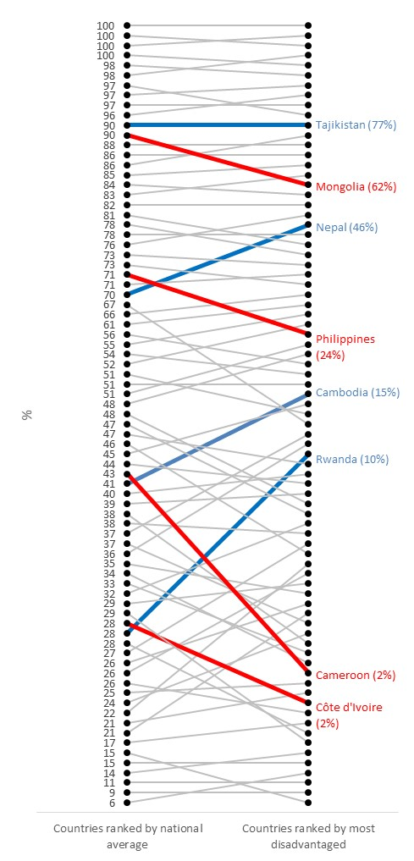

Note*:* The most disadvantaged group is defined in terms of sex, location and wealth.

Source*:* World Inequality Database on Education.

Figure 14.3: The poorest 20% of households have more than the poorest 20% of children

Percentage of population under age 18, by household wealth quintile, selected countries, 2013–18

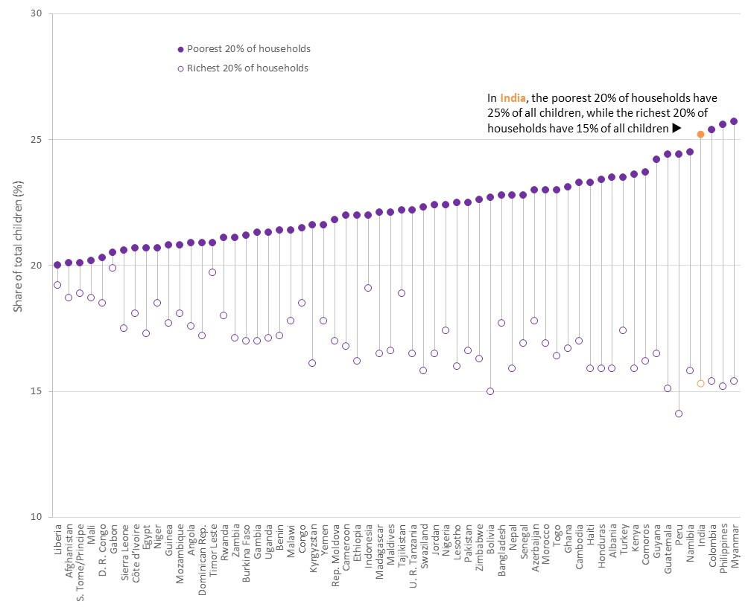

Source*:* GEM Report team analysis based on Demographic and Health Surveys.

The most marginalized groups with intersecting disadvantage suffer the worst education poverty, but data are scarce. Survey sample frames may not capture them, as with street children or nomads. Even when included, they may be difficult to identify, as with indigenous groups (**Focus 14.2**). Moreover, tools focused on these groups may not align with education indicator definitions, as with the new questions capturing disability (**Box 14.1**).

To monitor inclusion in learning, national and cross-national learning assessments must be inclusive. In 2019, the Technical Cooperation Group on SDG 4 indicators decided SDG thematic indicator 4.5.2 (percentage of primary education students whose first or home language is the language of instruction) can be reported based on information on language used in assessments until information on language of instruction becomes available. Data on many other education indicators are collected using survey instruments whose accessibility is poorly documented or studied. In practice, surveys may not be available in a language respondents or enumerators fully understand, compromising data quality (**Box 14.2**).

Box 14.1: Discontinuity in disability definitions can affect education indicators

The sixth round of the UNICEF Multiple Indicators Cluster Survey (MICS) is the first to use the best practice in disability measurement, the Washington Group Short Set of Questions, which is based on functional difficulties (see **Chapter 3**). Part of its sophistication is consideration of age-appropriate functional domains. The standard Washington Group questions underestimate the prevalence of child disability by omitting functions relevant to their life stage. The Module on Child Functioning implemented in MICS 6 overcomes this by applying different disability measures for children under age 5 and those aged 5 to 17 than for adults age 18 and above.

Yet age does not determine some functional domains. The appropriate meaning of disability does not change on turning age 18. Changes in relevant domains may occur slowly, as they relate to developmental stages for which age is a proxy. Others may change suddenly in response to situational changes, such as being in or out of school.

Figure 14.4: Interpreting education disability gaps is difficult when the measure and prevalence of disability changes at age 18

a. Prevalence of disability, by age, Iraq, Sierra Leone and Tunisia, 2017–18

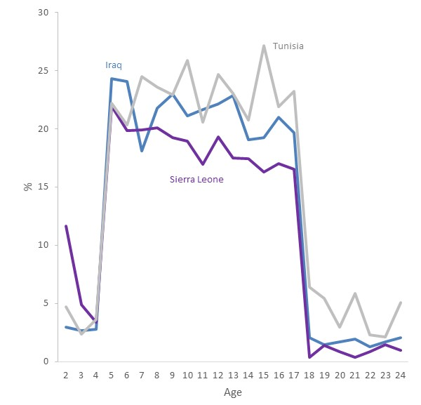

Source*:* GEM Report team analysis of MICS 6 data.

b. Age range of selected education indicators, Iraq, Sierra Leone and Tunisia

|  |  |  |  |  |  |  |  |
| --- | --- | --- | --- | --- | --- | --- | --- |
|  |  |  |  |  |  |  |  |
| Age | 14 | 15 | 16 | 17 | 18 | 19 | 20 |
|  |  |  |  |  |  |  |  |
| **Lower secondary education completion rate** |  |  |  |  |  |  |  |
|  |  |  |  |  |  |  |  |
| Iraq |  |  |  |  |  |  |  |
|  |  |  |  |  |  |  |  |
| Sierra Leone |  |  |  |  |  |  |  |
|  |  |  |  |  |  |  |  |
| Tunisia |  |  |  |  |  |  |  |
|  |  |  |  |  |  |  |  |
| **Youth out-of-school rate** |  |  |  |  |  |  |  |
|  |  |  |  |  |  |  |  |
| Iraq |  |  |  |  |  |  |  |
|  |  |  |  |  |  |  |  |
| Sierra Leone |  |  |  |  |  |  |  |
|  |  |  |  |  |  |  |  |
| Tunisia |  |  |  |  |  |  |  |

Threshold ages do not align with the definitions of several education indicators. Pre-primary education enrolment may refer to ages 3 to 5. When the age for the final grade of primary education is 13, the primary completion rate is defined for the age group 16 to 18. In many countries, upper secondary enrolment and attendance rates also refer to the age group 16 to 18. The youth literacy rate is defined over the age group 15 to 24. These and other indicators have in common straddling two disability measures within a survey.

The different approaches’ drastic effect on disability prevalence estimates hampers interpretation of disaggregating education indicators by disability. In Sierra Leone, disability prevalence falls from 16.6% among 17-year-olds to 0.3% among 18-year-olds (**Figure 14.4a**), while the lower secondary education completion rate is defined for ages 17 to 19 (**Figure 14.4b**). Average education outcomes for those with and without functional difficulties are impossible to interpret if having a functional difficulty is operationalized differently for individuals in an indicator age group.

There is no satisfactory solution other than not disaggregating by disability indicators affected by measurement discontinuity. Disaggregating functional difficulties by domain shows anxiety to be the largest, although not only, source of difference in prevalence rates between the Child Functioning Module and the Washington Group Short Set for adults. However, trying to align the two by ignoring the effect of this domain would not give valid measurement. A non-standard literacy rate for ages 18 to 24 could be calculated, or both Child Functioning Module and the Washington Group questions could be administered to ages 15 to 24.

## Box 14.2: The challenge of language in data collection tools should not be underestimated

Household surveys are an essential source of information about education systems, especially for analysing disparity in attainment and achievement by various characteristics. However, inattention to language of questions can compromise data quality. Major cross-national household survey programmes have rigorous training and quality assurance procedures. In other survey contexts, for instance humanitarian crises, minority language respondents often rely on unsupported local staff and enumerators to translate questions. This has implications for the design, reach and impact of education, especially in emergency contexts.

Research carried out by Translators Without Borders, a non-government organization, shows that many enumerators cannot understand surveys due to language barriers or cannot understand responses. Understanding abbreviations was especially difficult. In northeast Nigeria, just 31% of respondents understood ORS (oral rehydration salts), and 43% understood IED (improvised explosive device). Only 1 in 24 enumerators could explain the meaning of extremism (TWB, 2019). For open-ended questions, enumerators must typically choose from a list of answers best matching the response. Enumerators reported not always understanding English answer options and having difficulty identifying which best fit the response. They may then select answers they are confident they understand.

Even basic household data can be lost. The Rohingya word for young girl and adult woman is the same, potentially distorting the estimated number of children in households. For sensitive issues, translations may be stigmatizing, as is often the case with disability and mental health terms. Surveys should be based on a good mapping of languages spoken where enumeration will take place (TWB, 2020). They should be in plain language and put in local context, and terms enumerators might find hard to translate and use should be discussed. Enumerators should translate responses back into the survey language to ensure they have captured their essence. Recording and translating a sample of responses is a good quality control. Using home language is key to developing data collection tools.

Focus 14.1: How many children attend single-sex schools?

Disaggregation of enrolment by sex is routine in international education statistics, but comparative cross-country data on single-sex or co-education enrolment are scarce. Cross-national learning assessments, such as the Programme for International Student Assessment and the Trends in International Mathematics and Science Study (TIMSS), which collect information on student class and sex, offer valuable insights.

In about 60% of education systems in mostly upper-middle and high-income countries taking part in the 2015 TIMSS, less than 5% of primary schools were single sex. However, gender segregation in separate classes or schools is common in countries as diverse as Chile, Ireland, Israel and Singapore and is prevalent in many Muslim majority countries. The prevalence of single-sex schools generally increases in secondary education, for instance from close to zero for primary to almost one in five for lower secondary education in England (United Kingdom) (**Figure 14.5**).

In most countries, the proportion of students in single-sex schools corresponds to the proportion of such schools. Exceptions relate to the size of the type of schools that tend to be single-sex. In the Islamic Republic of Iran, single-sex primary schools (66%) enrol 84% of grade 4 students. One explanation is that public single-sex schools are larger than private co-education schools. By contrast, single-sex primary schools in the Russian Federation (8%) account for 1% of grade 4 enrolment, as single-sex religious and/or private schools are smaller, on average.

Although sudden changes in school system structure are rare, comparisons over time for countries participating in the 2007 and 2015 TIMMS capture some shifts. Single-sex schooling decreased in Australia and the Republic of Korea. The latter shifted to co-education schools in the 1980s, and a recent policy decisively favours co-education (Dustmann et al., 2018). The situation is more complex in Western Asia. In Jordan, the share of single-sex lower secondary schools and share of students attending them increased by 8 and 12 percentage points, respectively. One reason may be the influx after 2011 of Syrian refugees, who attended public single-sex schools. The share of single-sex schools decreased in Bahrain and Kuwait. Qatar saw single-sex primary schools decrease by half and a small increase in single-sex lower secondary schools. While public schools remain segregated in Gulf Cooperation Council countries, change is attributable to an increased share of private international schools. The United Arab Emirates introduced co-education primary schooling in 2018 (Dajani and Rizvi, 2018).

Figure 14.5: In many countries, a large share of schools are single sex

Percentage of single-sex schools attended by grade 4 and 8 students, selected countries, 2015

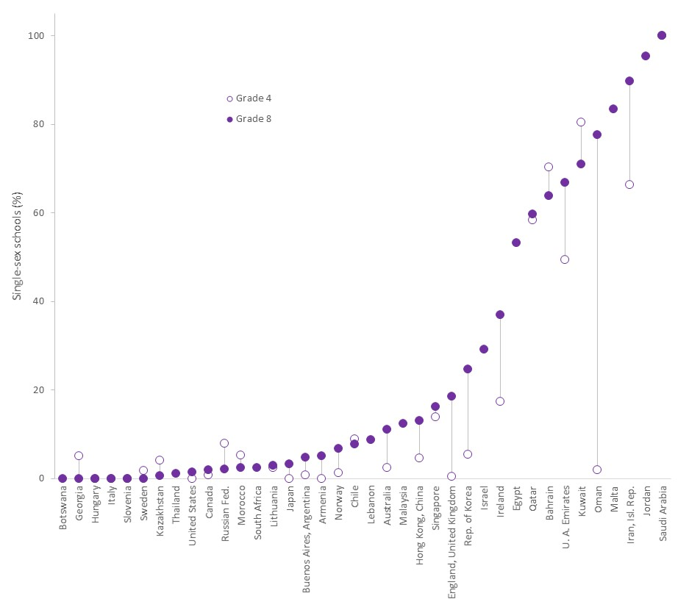

Source*:* GEM Report team calculations based on TIMSS 2015.

From a gender-inclusive perspective, single-sex schooling may be an acceptable temporary compromise when the de facto alternative in some culture- or country-specific contexts is females not attending (Marcus and Page, 2016; Sperling and Winthrop, 2015). Parents may prefer to send daughters to single-sex schools once they reach adolescence; lack of such provision in parts of Pakistan is one reported reason for low female enrolment (Aslam and Kingdon, 2008).

Some argue gender social dynamics are educationally counterproductive(Bigler et al., 2014). Females may show greater affinity for and achievement in science, technology, engineering and mathematics when less exposed to negative gender stereotypes about ability and males monopolizing equipment (Jackson, 2016; Marcus and Page, 2016). Yet single-sex schooling is unlikely to affect choices, attainment or achievement unless it challenges dominant notions of masculinity and femininity (Smyth, 2010; Younger and Warrington, 2006). The counterargument is that single-sex schooling can prevent females from developing social skills needed to navigate non-segregated workplaces and adult life (Fabes et al., 2013; Wong et al., 2018).

Evidence on the effects of single-sex schooling is mixed (Unterhalter et al., 2014). The main difficulty is isolating the characteristics of students likely to attend single-sex schools and the characteristics of segregated schools themselves from the single-sex schooling effect. In Thailand and Trinidad and Tobago, single-sex schools tend to attract wealthier females, overestimating the benefits (Arms, 2007; Jackson, 2012). A meta-analysis of 184 studies from 21 countries found that, while some showed modest learning outcome benefits of gender segregation, higher quality research that adjusted for confounding relationships showed little to no benefit and a slight negative effect on female education aspirations (Pahlke et al., 2014). The Republic of Korea provides one of few natural experiments, as students are randomly assigned to secondary schools (Link, 2012). A study exploiting this feature of the education system found that single-sex schooling had a small positive effect on achievement (Park et al., 2013).

The question is not which setting is better but why single-sex schools sometimes produce better outcomes and how the benefits can be replicated in more inclusive settings (Riordan, 2015; Sax et al., 2009). State-run primary schools in Malta have been co-education since 1980, while secondary schools were single sex until 2013. Due to this history and the many single-sex church-run schools, the prevalence of single-sex secondary schools is among the highest of non-Muslim majority countries. A study on the centralized lottery for Catholic school admission suggested that students with single-sex schooling made less gendered subject choices at later stages (Giardili, 2019).

Malta’s recent move towards public co-education occurred as part of a framework of policies to support and promote social inclusion. One benefit is easier inclusion and freedom of expression of lesbian, gay, bisexual, transgender and intersex students, who may be particularly excluded in single-sex schools premised on a homogeneous gender identity. With its recent Gender Identity Act, Malta adopted a comprehensive education policy focused on their needs – the first in Europe – including confidentiality and ending gender segregation in uniforms and some sports (Ávila, 2018).

Focus 14.2: Identifying indigenous groups in surveys and censuses is a challenge in Latin America

Latin America is characterized by wide and persistent disparity among ethnic groups (Bustillo et al., 2018; ECLAC, 2016; Telles, 2007). By most measures of well-being, including education, ethnic minorities are among those most adversely affected by the region’s development challenges (Hall and Patrinos, 2012; Telles et al., 2015). Yet, despite recent progress in collecting information on ethnicity, Latin America faces significant challenges in effectively targeting policies to indigenous peoples, as countries lack comparable data of sufficient quality on exact numbers and distribution. Capturing indigenous identity in surveys is hampered by its many dimensions and further complicated by historical nation-building processes that embraced *mestizaje*, or mixing of ethnic and cultural groups, which made indigenous peoples invisible (Paredes, 2018; Soto Quirós and Díaz Arias, 2007; Telles et al., 2015).[1]

There is lack of consensus in the region on how to measure ethnicity. Self-identification is the prevalent approach, but countries have also used four alternative criteria: official recognition of identity, common origin, territoriality and cultural-linguistic factors (Del Popolo, 2008). Countries apply these criteria in various ways in data collection instruments. For instance, in addition to self-identification, Mexico applies an official household-level criterion defined by the National Commission on Indigenous Peoples: indigenous people are those living in households whose heads (or their spouses and ancestors) speak an indigenous language (CDI, 2017).

Figure 14.6: Official identification criteria capture most speakers of indigenous languages in Mexico but only a fraction of those who identify as indigenous

Percentage of indigenous people according to three definitions and overlaps, Mexico, 2018

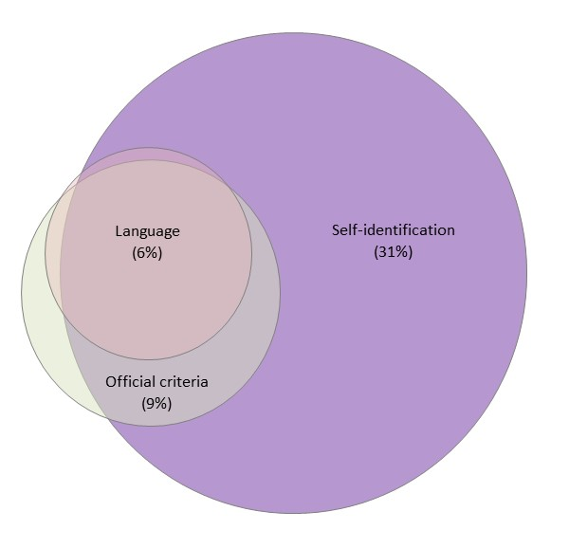

Source*:* GEM Report team calculations based on Valencia-Lopez (2020).

Demographic shifts have blurred ethnic boundaries and given rise to fluid indigenous identities and imperfect congruence between criteria (**Figure 14.6**). Indigenous population estimates vary considerably, depending on the criterion (INEE, 2017; Telles and Torche, 2019). Six countries in the region have data on both self-identification and linguistic criteria: Bolivia, Paraguay, Mexico, Peru, Ecuador, and Guatemala. Peru has the highest proportion of self-identified indigenous people (almost two in three). In Paraguay, 1.7% self-identify as indigenous, while approximately three in four speak an indigenous language – the highest proportion in the region. Ecuador has the lowest proportion of indigenous speakers (4.8%).

Self-identification is the increasingly dominant criterion, consistent with the International Labour Organization’s Indigenous and Tribal Peoples Convention. However, used alone, it can provide inconsistent estimates of education inequality. Education outcomes of speakers of indigenous languages are often worse, compared with self-identified indigenous people who only speak Spanish (INEE, 2017; Planas et al., 2016). Across four national household surveys in 2018, school attendance among 15- to 17-year-olds in the Plurinational State of Bolivia, Guatemala, Mexico and Peru was 3 to 10 percentage points lower among speakers of an indigenous language than among all those self-identifying as indigenous (Valencia Lopez, 2020).

Exclusive focus on self-identification may reinforce the narrative that ethnic differences result from class disparities. Skin colour tends to be a better predictor of years of schooling than the census criterion, especially after controlling for social class (Flores and Telles, 2012). Recent research in Brazil, Mexico and Peru showed persistent inequality by skin colour, language and, in some countries, self-identification, after controlling for social class (Pérez Cárdenas, 2018; Telles et al., 2015; Villarreal, 2014).

Indigenous groups defined by different criteria may have distinct education needs. Education policy responses in countries with low concordance of self-identification and indigenous language vary. Mexico enforces intercultural indigenous curricula in schools with high levels of self-identified indigenous groups but whether these are administered in an indigenous language depends on how many students speak it (reference).

One reason for the discrepancy in education outcomes between indigenous groups identified according to identity or language may be insufficient household- or school-level language transmission and a resulting shift in identity. There is evidence indigenous individuals do not identify their children as having their ethnicity, reflecting a fluidity over generations (Villarreal, 2014). Individuals may also change their self-perceived ethnic identity.

Mexican National Household Living Conditions Survey longitudinal data offer insights into the fluidity of ethnic identity. The ethnicity question is comparable over time, and responses are individual rather than by household head as proxy. Individuals who identified as indigenous in the first wave in 2002 exhibited high levels of fluidity: half had changed ethnic identity at least once by 2009. Education level is associated with more constant self-declaration of ethnicity, consistent with the ethnic pride hypothesis. Speaking an indigenous language is also associated with lower likelihood individuals declare themselves non-indigenous in a subsequent wave. Living in a city reduces the likelihood of consistent indigenous identity.

Urban migration and loss of indigenous language proficiency over generations triggered complex processes of negotiating identity. Anthropological research has documented how the presence of indigenous peoples in urban areas led to new forms of indigenous identity expression (Gomez Murillo, 2008). In Guatemala and Mexico, urban migration resulted in loss of indigenous languages, once the main marker of indigenous identity, as indigenous peoples access local, predominantly Spanish-speaking labour markets (Telles and Torche, 2019; Yoshioka, 2010).

1. This Focus is based on Valencia Lopez (2020).